**ADBMS assignment 3**

**Anushka Singh**

**15070121109**

**Write and implement PL/SQL functions.**

1. **Write a PL/SQL function to find the sum of the 1st 100 even numbers.**

create or replace function evenadd

return number

is

result number :=0;

begin

for num in 1..200 loop

IF mod(num,2)=0 then

result := result+num;

END IF;

end loop;

return result;

end;

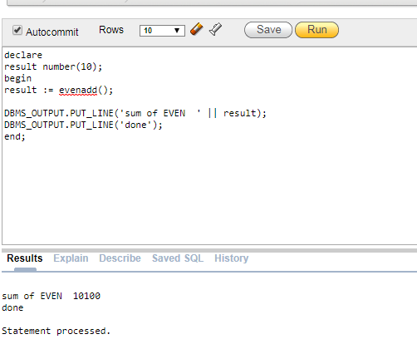

1. **Write a PL/SQL function to check if a number is prime or notices.**

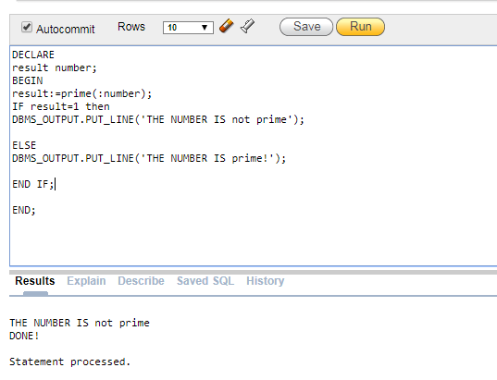

1. **Write PL/SQL function to find all the managers. Consider the schema Emp(Emp_no, Company, DOJ, Designation, Salary, Dep_No)**

create table emp1(emp_no int , Company varchar2(10), DOJ date, Designation varchar2(10),Salary int, Dep_No int,primary key(emp_no)); insert into emp1(emp_no , Company , DOJ , Designation,Salary , Dep_No ) values(3, 'sbi','11/01/2015','manager',45000,205); 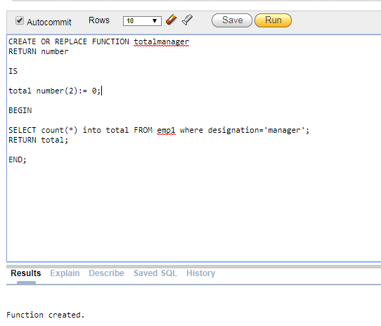

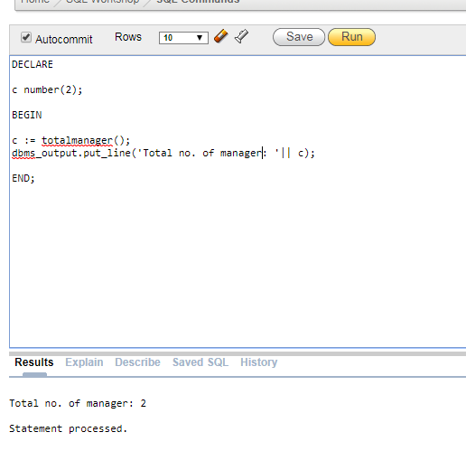

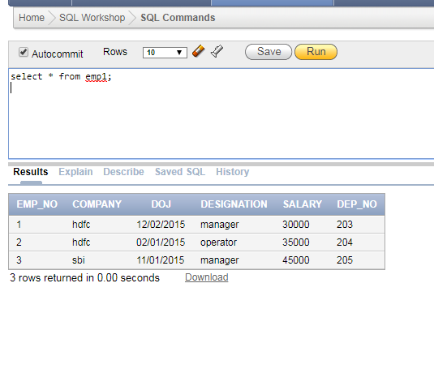

1. **Create a function to find number of employees earning salary more than 10000 Rs.**

create or replace function emp_sal

return number

is

total number;

begin

select count(*) into total from emp where salary>10000;

return total;

end;

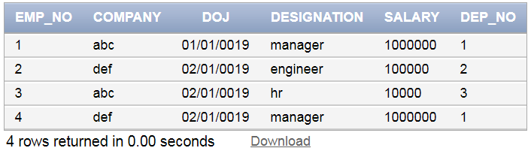

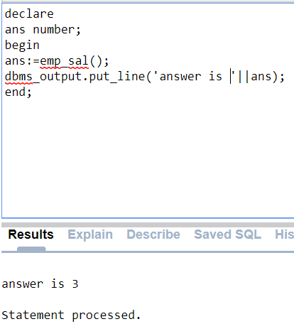

1. **Write a PL/SQL function to display highest paid employee name.**

create or replace function emp_maxSal

return number

is

total number;

begin

select emp_no into total from emp where salary=(select max(salary) from emp);

return total;

end;



